**ConfigZone**

**Product Overview**

ConfigZone is an IBM Infrastructure management tool.

It provides a number of enhancements to help support, protect, maintain and document your IBM systems architecture. It saves on administration time allowing less staff to do more.

This includes the following:

* Automated System Configuration documentation
* Problem Reporting – proactively highlighting potential issues.
* Ability to perform diagnostics without accessing the systems
* Hardware overview showing allocation of resources
* Storage Systems overview and Virtual Disk Mappings
* Reporting Tools
* Software Inventory
* Backup Reporting
* Extensive Virtual IO Server Configuration Overview
* Performance graphs for AIX LPARs and VIO Servers
* Security Reporting with over 300 checks.

No extra servers or hardware is needed to setup ConfigZone. It can be placed on an existing NIM server that is already part of the IBM Infrastructure.

**Configuration**

The configuration settings for IBM Servers, VIOs, LPARs and Storage systems are automatically generated from the systems, this ensures that the information displayed on the ConfigZone website is always up to date as opposed to creating manual documentation using Word or Excel which can usually become outdated and obsolete.

Anyone who does not have administrator access to the IBM systems can view information regarding their systems via the website.

Diagnostics can also be carried out using the information presented on the website, in fact the ConfigZone collection script can be run on any AIX system and the resulting output used to perform a HealthCheck on that systems without having access which is a great way of obtaining new IBM customers.

The information on the website can be used to help recover the configuration of systems in case of a DR situation.

**Problem Reporting**

Any errors picked up during the collection of system configuration is presented on the Problems page.

This is the only page that needs to be monitored to help with supporting the IBM Infrastructure.

Errors can be whatever a customer wants to see as the collection script is completely customizable, if it can be put in a script then ConfigZone can report on it.

**Hardware Overview**

HMC (Hardware Management Console) is the centralised management system for IBM Power Servers.

Configzone gives a complete overview of hardware allocation and virtualization configuration of the Power Servers on a single view. It is easy to see exactly where resources (CPU, Memory and Adapters) have been allocated and what resources are still available to be used.

The Storage reporting within ConfigZone shows available space in disk pools and what virtual disks are allocated to LPARs. This works with all IBM Storage systems (DS, Storwize and Flash).

The Infrastructure overview page provides detail at a device level such as serial numbers and Firmware levels.

**Software Inventory**

ConfigZone can help you keep track of versions of software installed across the entire system. On a single page it is easy to view levels of AIX, VIO and software installed on each LPAR. The firmware and microcode installed on the Power Servers and Storage Systems is also available to make sure that you are always up to date.

**Performance Reports**

Every LPAR is setup to run NMON (this is built in to AIX) performance monitor. Output from this is converted to GoogleChart format which creates multiple graphs for each system sent to ConfigZone daily. These are useful for diagnosing performance issues you may be experiencing.

**Backup Reports**

ConfigZone can keep track of the various backups taken for the Operating System (MKSYSB-rootvg) and Application (non-rootvg). These reports will also display the contents of the backups.

**VIO Server Configuration**

As 90% of Power systems now use Virtual I/O Servers to manage virtualisation of hardware these are the most important LPARs on the system. Correct and updated documentation for these is vital.

ConfigZone details PowerVM Virtual I/O Server like no other tool available.

The information contained in the VIO Server configuration page covers everything from storage mapping via VSCSI & NPIV (physical and logical devices) to the network via Shared Ethernet. Information about the SEAs is detailed in full including Etherchannel settings, the virtual and physical devices and the VLANs configured.

**Production Overview**

Gives a single screen view of the main systems – this is completely customizable to suit each businesses requirements. For each LPAR you can view the status of filesystems/PowerHA/GPFS/Running Applications etc etc.

**See Example of output on the next few pages….**

**Performance charts for every LPAR…**

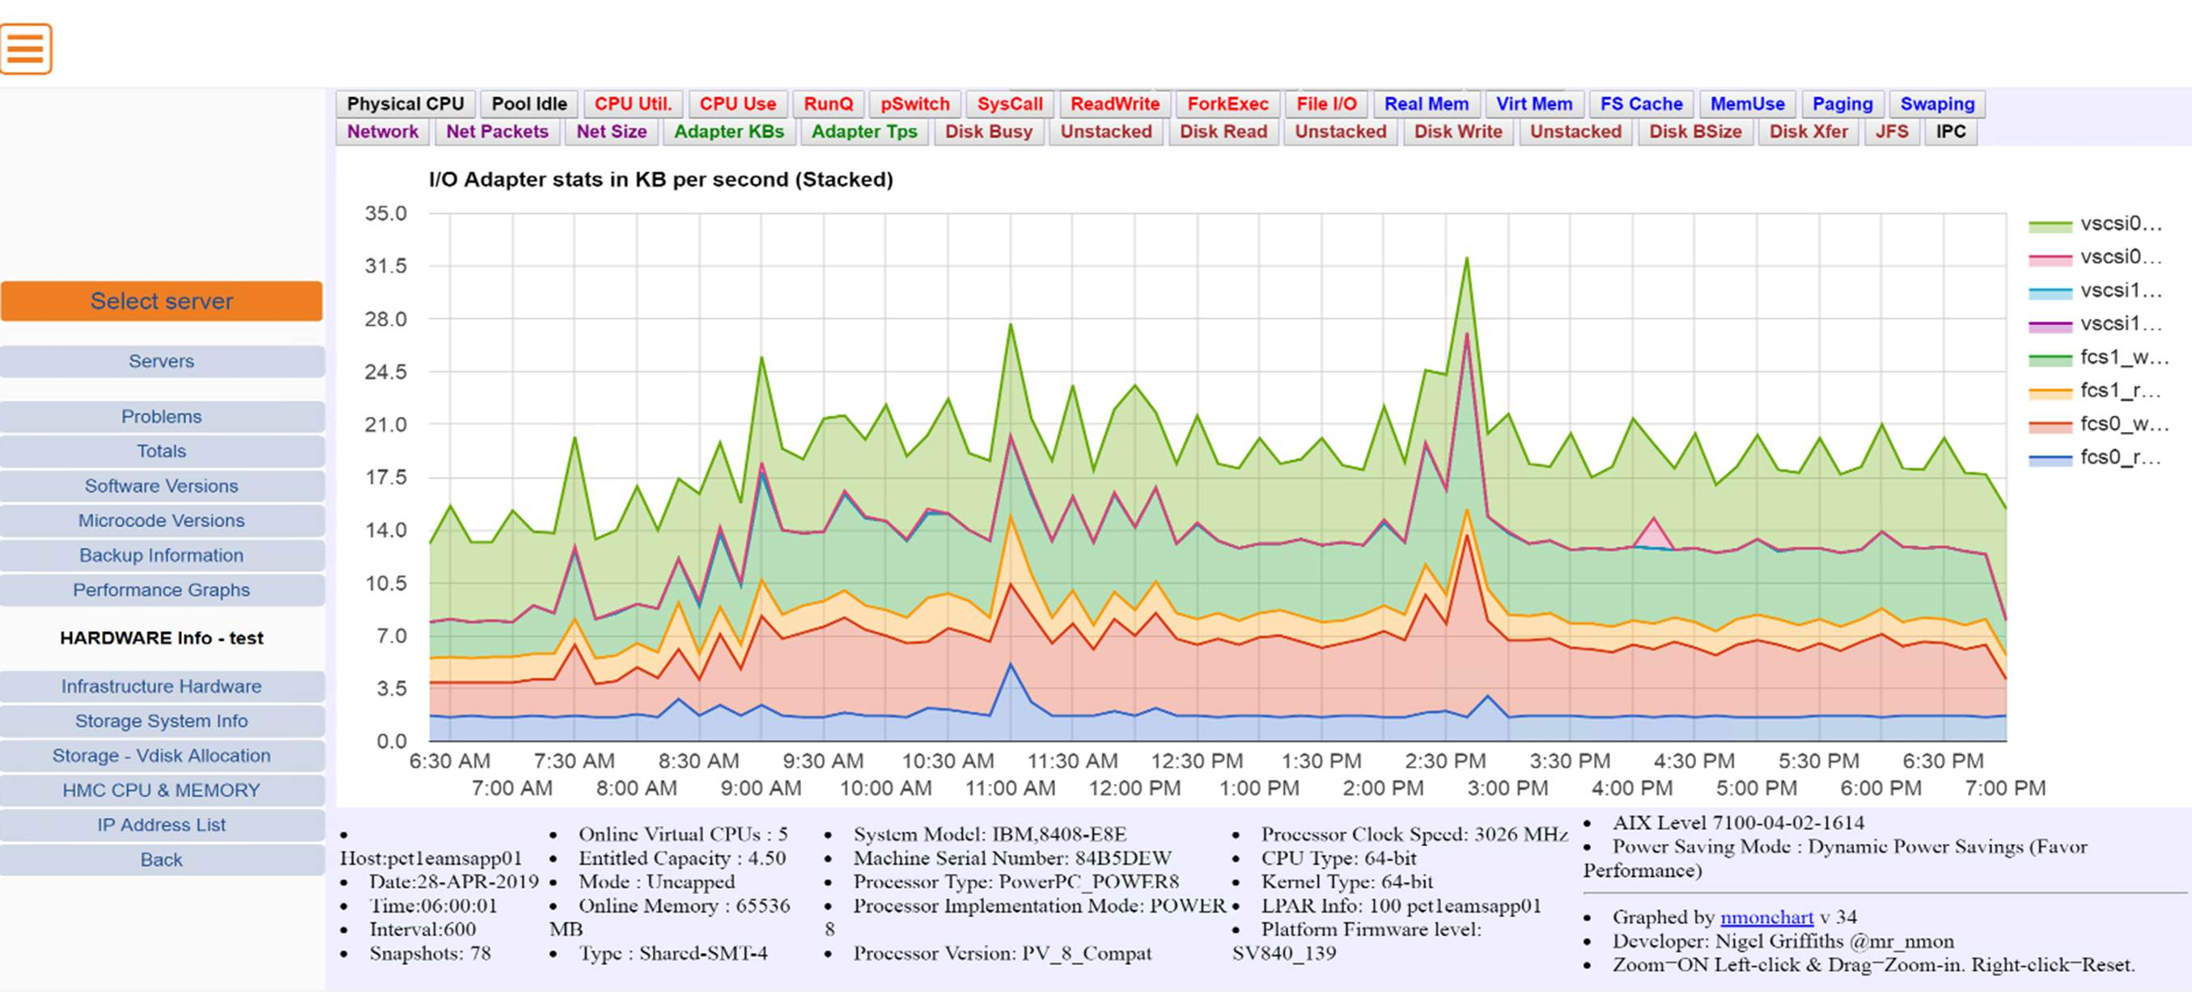

**Problem page – real time alerts listed here ….enabling us to be pro-active not reactive**

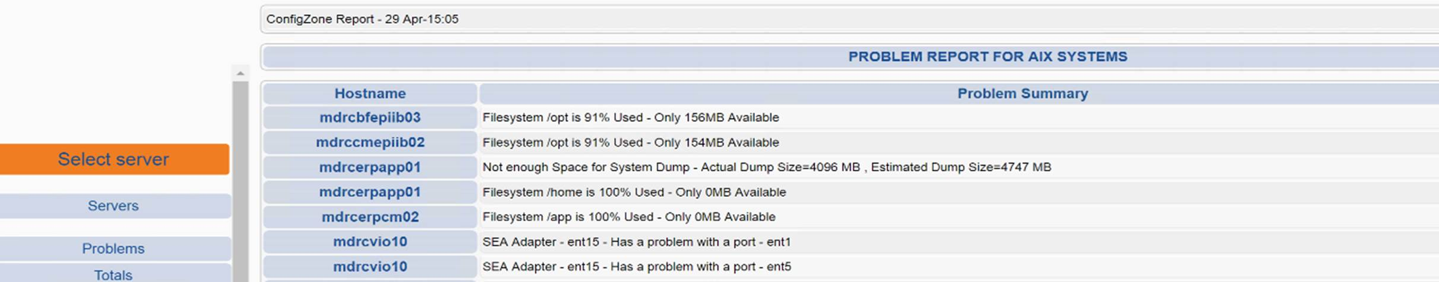

**Software Installed …**

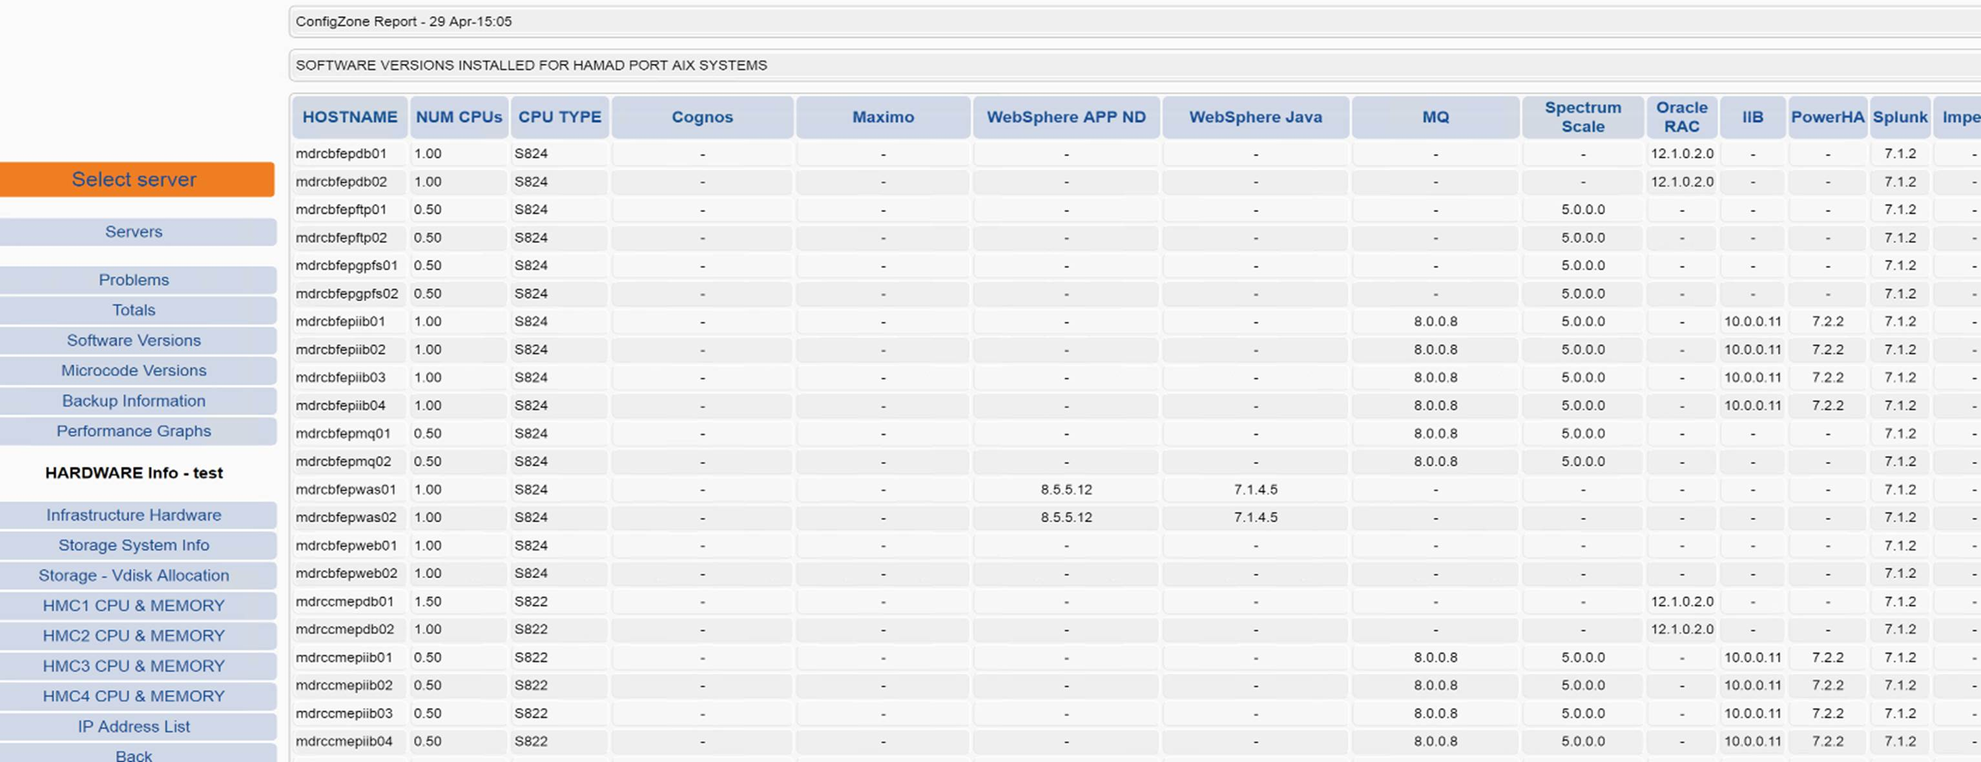

**Hardware Page with Event information**

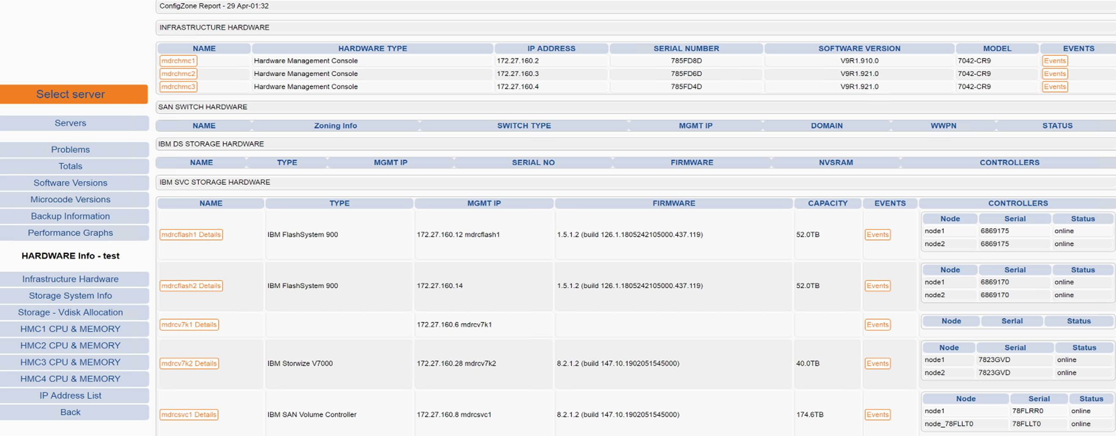

**Server and LPAR Information**

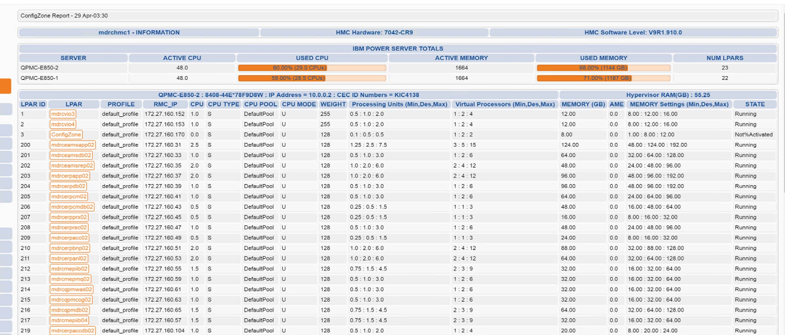

**VIO Server Configuration**

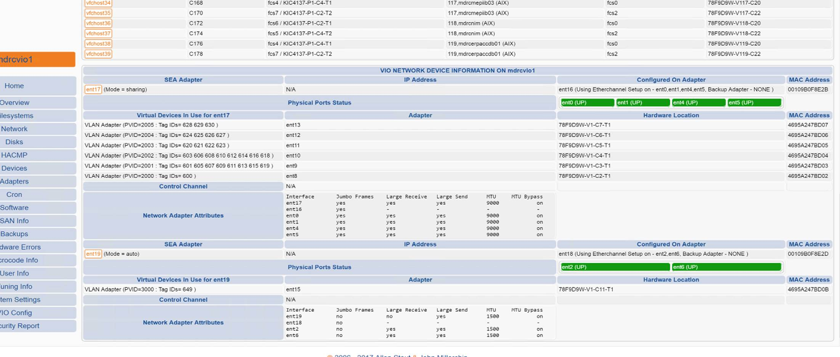

**Plus all information for every LPAR …**

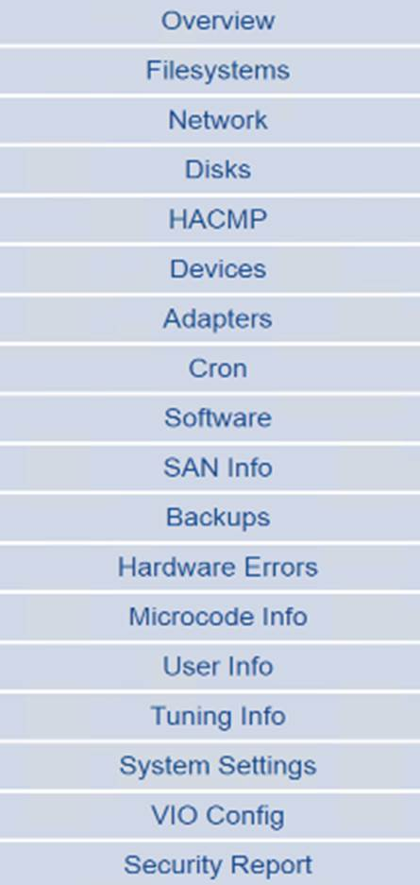

**Production Status Page**

